

Questions and Answers on the Cluster Lead Organization RFA’ Application Process:
Question 1:
Could you please confirm whether the deadline is February 12 or February 15?
Answer 1:
The deadline for submitting applications is February 15, 2026. Please refer to the RFA for the full details of the submission.

Question 2:
The hyperlink provided for the “Request for Applications” leads to the same document as the “Application form”. Could you please confirm if there is another document for this call?
Answer 2:
Please find the following links for “Request for Applications” and for “Application Form”.

Questions 3:
Is the currently open Request for Applications (RFA) under the Higher Education for Innovation and Growth (HEIG) Activity limited exclusively to clusters related to the Agri-Food Security sector, or is it possible to incorporate other sectors as well?
Answer 3:
This Request for Applications is limited to the Agri-Food Security sector.

Question 4:
Can you share the RFA document for the Higher Education for Innovation and Growth (HEIG) Activity?

Answer 4:
The following link contain the RFA documents for the Higher Education for Innovation and Growth (HEIG) Activity. Application Form and Budget Template.

Question 5:
Can you share the editable versions of the following required attachments:
· Attachment 1: Application Form (Word format)
· Attachment 2: Application Budget Template (Excel format)

Answer 5:
The following links contain the editable versions of Application Form and Budget Template.

Question 6:
Do consumable supplies budgeted for training and activities fall under the activities budget line, or should they be included under the equipment and supplies budget category?

Answer 6:
The consumable supplies budgeted for training and activities should be budgeted under
Other Direct Costs (Activities) category.
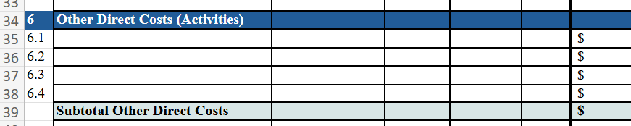

Question 7:
Does the travel budget category include local transportation?

Answer 7:
There’s no budget category for travel in the Budget Template, but you can add a budget line for local transportation needed for the project implementation only.

Question 8:
The RFA indicates that applicants should contact HEIG to receive the Request for Application and the application package. We note that the application template and budget template have been uploaded to the website. Could you please confirm whether these documents constitute the full application package, or if there are any additional materials that need to be requested separately?

Answer 8:
Applicants are requested to use the Application Form and Budget Template uploaded in the website when preparing their submission. In addition, please carefully review and follow the guidelines outlined in SECTION IV: APPLICATION AND SUBMISSION INFORMATION mentioned in the Request for Applications as these provide important information on eligibility criteria, required documentation, and submission procedures.

